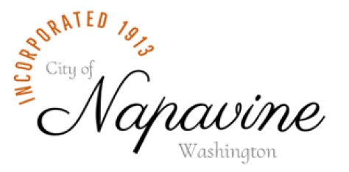
______________________________________________________________________________

407 Birch Ave SW, P. O. Box 810
Napavine, WA 98565
Phone: (360) 262-9344
www.cityofnapavine.com

PASS-THROUGH DEVELOPER FEES AGREEMENT

Developer: _____________________________________________________________________ Date: ___________________
Address: ________________________________________________________________________________________________________
City: __________________________________________________ State: ___________ Zip Code: ___________________
Phone Number: _____________________________________ Email: _____________________________________________

I, ____________________________________________ of _________________________________________________________________
(Name) (Development Firm)

hereby acknowledge and understand that the City of Napavine may have pass-through fees outsourced for engineering, legal review, and other professional services. The Community Development Director may determine if any pre-application site plan requires any pass-through services upon submittal.

- A deposit in the amount of $1,000.00 plus a non-refundable $500.00 administration fee totaling $1,500.00 is due at time of submitting application for the need of pass-through services if deemed required by Community Development Director.
- A payment of incurred costs for pass-through review must be paid before moving forward with the application when available or within fifteen (15) days, whichever occurs later.
- If there are no funds held in trust or the amount deposited is insufficient to cover the Pass-Through Fees and Charges, the City Treasurer shall invoice the Applicant for the Pass-Through Fees and Charges as they are incurred by the City, providing for twenty (20) days to remit balance due.
- All incurred outside source costs are due before a permit will be issued.
- Failure to pay pass-through fees within thirty days (30) of invoice will result in application being deemed abandoned causing the applicant to start the application process anew; any deposits received by the city, less the $500.00 administrative fee, will be applied to any unpaid Pass-Through Fees and Charges, and the remainder if any, refunded. Any remaining balance due and owing beyond the deposit will accrue interest at twelve percent (12%) per annum.
- If the Applicant fails to take substantial steps to complete the project within one year, City will revoke any permits previously issued and deem the project abandoned. Upon the project being deemed abandoned, the City will refund any unused amounts held by the City less the $500.00 administrative fee. If the amount held by the City is not sufficient to pay any outstanding invoices, the City shall have the right to lien the property being developed pursuant to Chapter 60.04 RCW.
- Any balance remaining from the deposit less the Administrative Fee will be refunded within thirty (30) days of project completion and approval/acceptance by the Community Development Department.
- Prior to filing any lawsuit, an Applicant shall appeal any decision by a City Employee over the interpretation or application of the Pass-Through Fees and Charges Agreement to the City Council at an open public meeting. The City Council shall issue its decision on the appeal within twenty-one (21) days of the hearing.

________________________________________________ ____________________________________
Signature Date

_______________________________________________ ___________________________________
Community Development Signature Date

