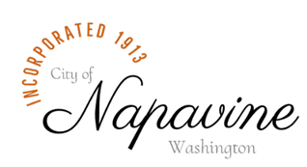
NAPAVINE CIVIL SERVICE COMMISSION MEETING
AGENDA

Tuesday June 16, 2026 @6:00 PM

James Pea,
Chairman,
jpeacivilservice@cityofnapavine.com

Charles Rollo,
Commissioner
crollocivilservice@cityofnapavine.com

Heidi Marshall,
Commissioner
hmarshallcivilservce@cityofnapavine.com

Kimberly Alexander,
Secretary/Examiner
kalexandercivilservice@cityofnapavine.com

City of Napavine
407 Birch Ave SW
P O Box 810
Napavine, WA 98565
360-262-3547

City Website
www.cityofnapavine.com

CIVIL SERVICE COMMISSION MEETING HAS BEEN CANCELLED DUE TO THE LACK OF AGENDA ITEMS

Next Meeting is July 21, 2026 @6:00 PM

